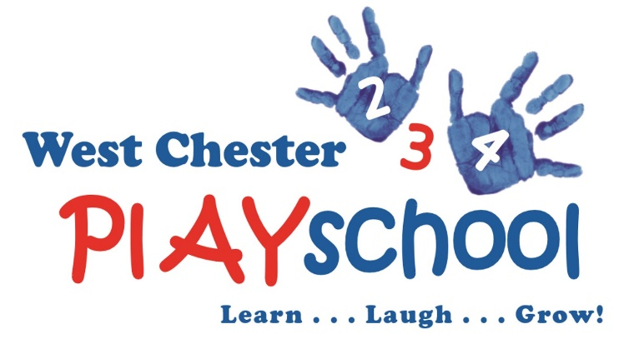

Our afternoon Enrichment Program at West Chester Playschool is from 12:00 – 2:00 or 12:00 – 3:00, depending on the enrichment program selected (see below). Parents may opt to have their child bused from Pocopson Elementary morning kindergarten to Playschool (We must have a minimum of five students to provide busing). The students will eat a parent provided lunch, have both indoor and outdoor play and there will be a theme based activity each day. For more information about West Chester Playschool, please visit our website www.westchesterplayschool.org.

Fall 2017 Activity Registration Form
Student Name_______________________________________________________
Student Address_____________________________________________________
Mother’s Name______________________Mobile Number___________________
Father’s Name_______________________Mobile Number___________________
Emergency Contact Name______________Mobile Number___________________
Any Allergies? No____ Yes____ Explain:_________________________________
Please check appropriate box(es):
- Spanish Class
  - Dates: Monday, September 11th – Monday, November 13th
  - Time: 12:00 – 2:00pm
    - Lunch and Play from 12:00 – 1:00pm
    - Spanish Class from 1:00 – 2:00pm
  - Cost $250 for the session
  - Transportation from Pocopson Elementary to WCPS is an additional $145 per session

- Soccer Shots
  - Dates: Wednesday, September 13th – Wednesday, November 15th
  - Time: 12:00 – 2:00pm
    - Lunch and Play from 12:00 - 1:30pm
    - Soccer Class from 1:30 – 2:00pm
  - Cost $265 for the session
  - Transportation from Pocopson Elementary to WCPS is an additional $145 per session
* Please attach a check to this completed registration form for the appropriate amount as noted above and remit to West Chester Playschool 725 West Miner Street West Chester, PA 19382

