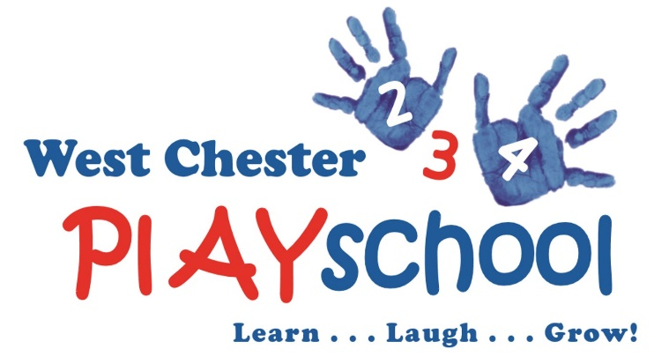

Our afternoon Activity Program at West Chester Playschool is from 12:00 – 2:00. The students will eat a parent-provided lunch, have both indoor and outdoor play and there will be an activity from an outside vendor taught each day. For more information about West Chester Playschool, please visit our website www.westchesterplayschool.org.
Winter 2019 Activity Registration Form
Student Name_______________________________________________________
Student Address_____________________________________________________
Mother’s Name______________________Mobile Number___________________
Father’s Name_______________________Mobile Number___________________
Emergency Contact Name______________Mobile Number___________________
Any Allergies? No____ Yes____ Explain:__________________________________
Please check appropriate box(es):
- Spanish Class
  - Dates: Mondays January 7th – March 11th
  - Time: 12:00 – 2:00 pm
    - Lunch and Play from 12 – 1 pm
    - Spanish Class from 1:00 – 1:30 pm (New Students)
    - Spanish Class from 1:30 – 2:00 pm (Returning Students)
    - Cost $200 for the 8-week session (No class January 21st and February 18th
    - Your child will have additional playtime while not in the Spanish class

- Karate
  - Dates: Wednesdays January 9th – March 13th
  - Time: 12:00 – 2:00 pm
    - Lunch and Play from 12:00 – 1:30 pm
    - Karate from 1:30 – 2:00
    - Cost $250 for the 10 – week session

- Super Duper Sports
  - Dates: Thursdays January 10th – March 14th
  - Time: 12:00 – 2:00 pm
    - Lunch and Play from 12:00 - 1:30 pm
    - Super Duper Sports Class from 1:30 – 2:00 pm
    - Cost $250 for the 10 - week session

* Please feel free to email a copy of this registration to director@westchesterplayschool.org and we will send you will be invoiced for the activities you choose on November 1st.

I AM RESERVING THE WEEK OF MARCH 18TH FOR ANY NECESSARY MAKE-UP CLASSES DUE TO SNOW DAYS. IF WE DO NOT USE OUR SNOW DAYS, WE WILL HAVE ACTIVITES SCHEDULED FOR THOSE DAYS.

